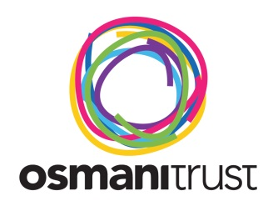

The Snowdonia Charity Challenge

FAQs

How do we travel to Snowdonia?
You will travel from the Osmani Centre 58 Underwood Rd London E1 AW. Please ensure you are on time as the coach cannot wait for individuals.

What shall I wear?
Wear comfortable clothes e.g. loose trousers or bottoms and a loose top.

How about trainers?
We recommend light hiking boots for ankle safety.

Do I need to bring my own food and water?
We will provide sandwiches and light refreshments for main meals and water. Bring small snacks/packed lunch with you to keep you going as service stations are heavily priced.

Are there toilets on the way up?
On the day of departure, try to control what you eat for breakfast and the night before, as there are no toilets on the way up. From previous experience, even after drinking a lot of water, a lot of it tends to be used up in re-hydrating your body. There are toilets on the coach

Will there be any professional guides?
Yes, there will be an experienced staff member to guide us.

Will there be any qualified first-aiders?
Yes there will be a qualified first-aider.

How long will it take to complete the trek?
We intend to start the Snowdon trek at 12.30pm. We will stop a couple times for breaks. We aim to complete the whole trek in roughly 5-7 hours. Should you have any questions that have not been covered in this pack please feel free to get in touch with the organisers.

Medical information
Trekking is a strenuous activity and you should therefore, be reasonably fit and enjoy sufficient good health to participate. Remember, you will be hiking for several hours in one day over steep terrain!!

Further information
Contact Kamrul Islam on 020 7247 8080 or email Kamrul.islam@osmanitrust.org
Or visit our website: www.osmanitrust.org

: www.facebook.com/OsmaniTrust : www.twitter.com/osmanitrust

