The Snowdonia Charity Challenge

Are you up for a challenge?
Do you want to help vulnerable young people and families?
Are you daring and brave enough to climb Mount Snowdon?

Join us for the Osmani Snowdonia charity trek on the 17th of October 2015 (Saturday)
Why Fund Raise?
To support the Osmani Trust to provide a range of vital youth, health, mentoring and training/employment services to vulnerable and disadvantaged young people, adults and families across Tower Hamlets and East London.
Itinerary
Saturday 17th October 2015
Coach Departure 6.00am from Osmani Centre car park London E1 5AW
We should have one stopover along the way. We advise plenty of rest during the journey for a long day ahead!
Arrive at Snowdonia at 12pm
12.30pm Trek up to Mount Snowdon together and enjoy the breath-taking natural landscape.
We will depart Snowdonia by 7pm to arrive back at Osmani Centre around midnight. Please ensure you arrange your own transport to get home after we return to Osmani Centre as it will be around midnight.
Registration
Registration Price = £25 per person
Price includes:
• Travel via coach from London,
• Sandwiches / refreshments
• Trek of Mount Snowdon

How to register:
• You will need to complete an online application form. http://www.eventbrite.co.uk/e/snowdonia-trek-for-osmani-trust-tickets-18165455366
• Pay £25 to secure your place.
• Set up a Virginmoneygiving page to fundraise. Please note: to participate a minimum sponsorship of £200 is required from friends, relatives etc.
Once you’ve registered to participate the next step is simple:
Setting up a fundraising page… Here are the instructions below:
http://uk.virginmoneygiving.com/giving/
Then click on ‘step up a fundraising page’ followed by ‘Personal Challenge’
Then please fill in the details as below…
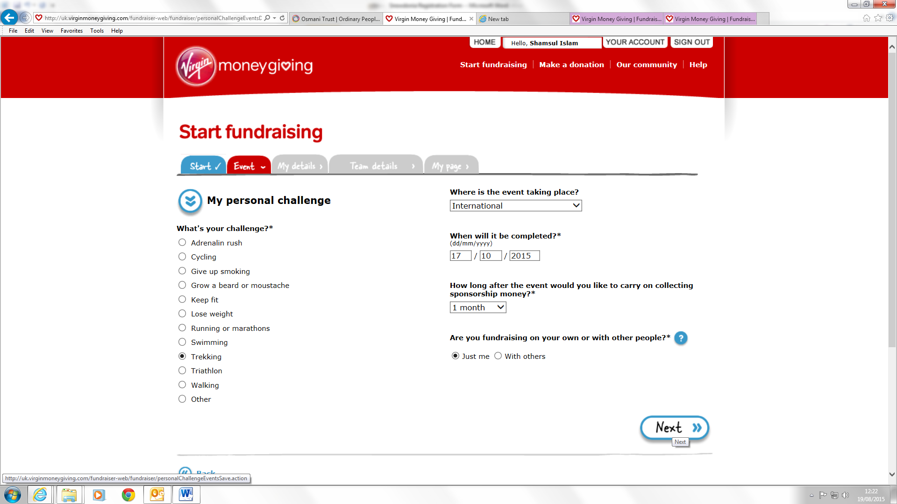
Followed by
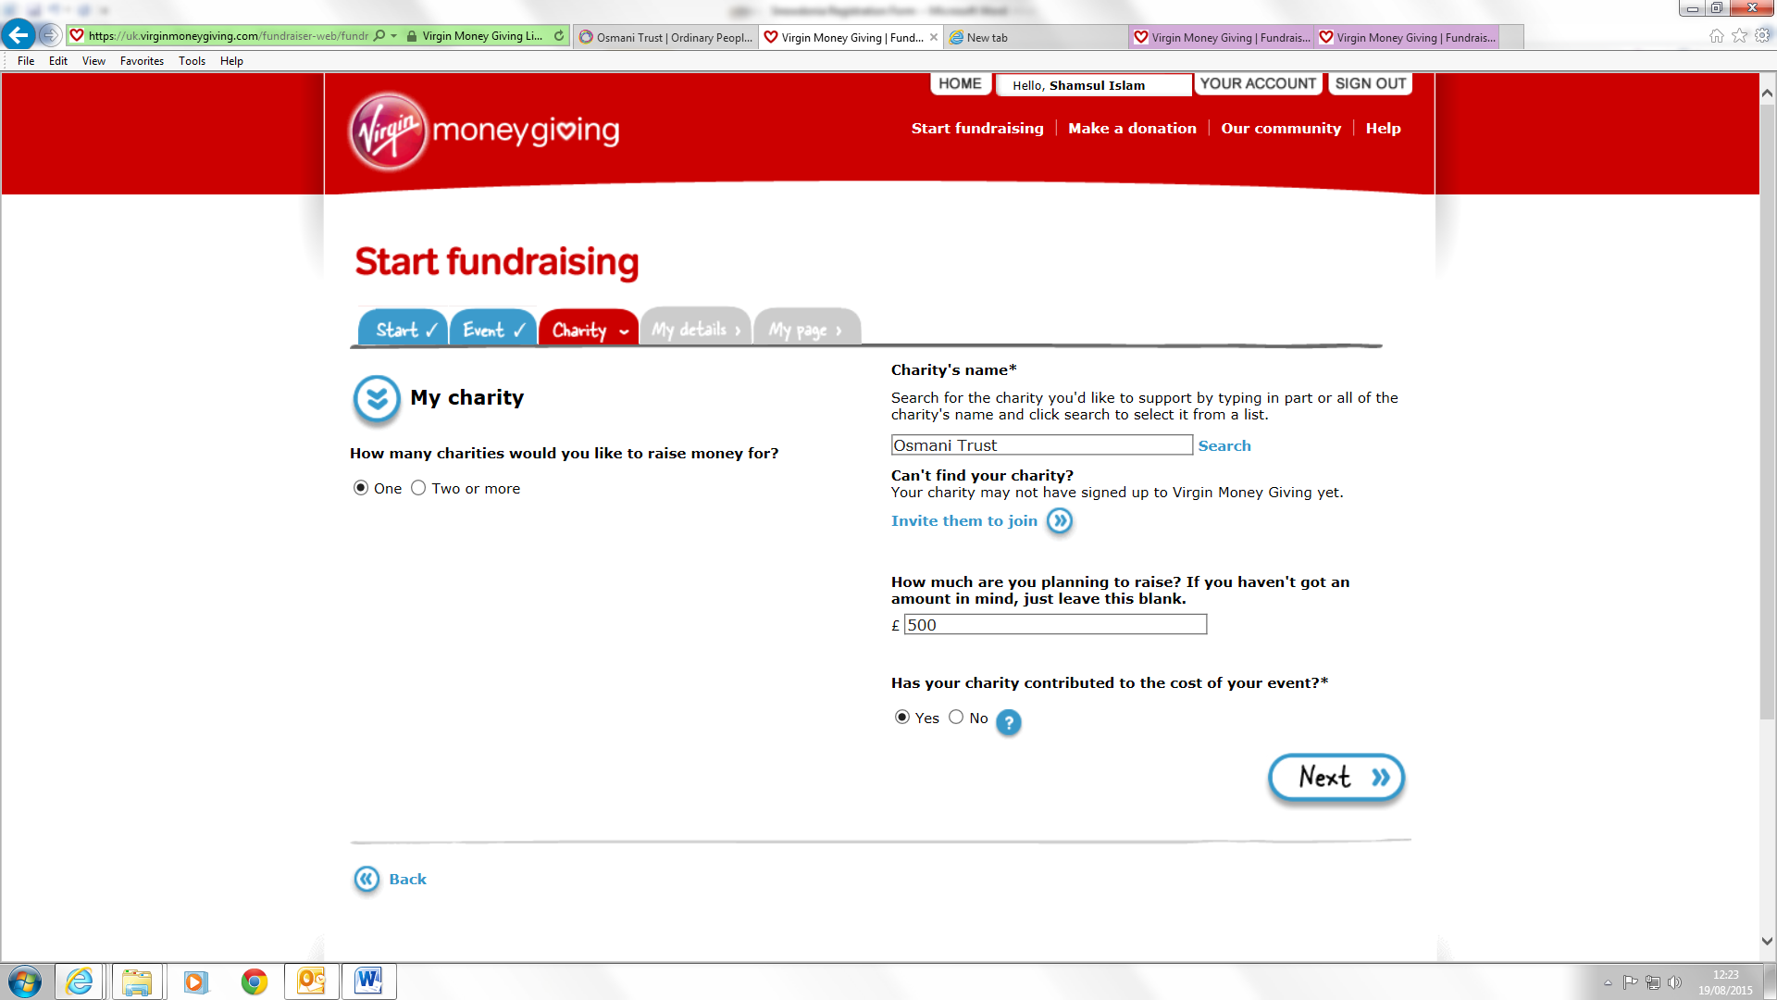
Make sure you search ‘Osmani Trust’ and click select.
All you do in the next step is register you details and create your page and start fundraising for Osmani Trust. Happy fundraising!!
Don’t forget the top 3 fundraisers will receive mystery prizes!

Fundraising Tips
We are asking everyone to raise a minimum of £200. This may seem a lot but is not as hard as it seems.
Here are some tips.
Compete against your friends taking part. The competition can bring some excitement into fundraising and can force you to challenge your own fund raising abilities. Why not set up a weekly fundraising league table so your friends can all see how everyone is getting on?
Help encourage those lagging behind and motivate others to climb up the league table. Each participant can create their own Virginmoneygiving page which we highly recommend.
Reminders!
Once you have made everyone you know aware of your fundraising challenge be sure to update your contacts on how the fundraising is going, but don’t overdo it to annoy them.
It’s a good protocol to send a reminder email or text a few days before doing the challenge, and then send an update email or text after completing the challenge. Also try to secure as many verbal pledges as possible that way you can remind these sponsors as much as you want until they actually donate.
You may have to be quite persistent to secure the verbal pledges, but it’s all for a worthy cause. A good way around this is to arrange a get together with a group of friends and then when you feel it is appropriate, mention your charity challenge and be blunt and pose the question “So are you going to sponsor me?” Believe me, without doing this, you probably won’t raise as much as you potentially could.
People are so busy these days that they may see your email or text and intend to sponsor you, but then get side tracked and totally forget. From experience we know tracking down sponsors can be very difficult and time consuming. This is why we are recommending that everyone sets up Virginmoneygiving page

Equipment
Foot wear
The ideal boots for climbing should have a good grip, protect ankles, should be water proof and breathable. If you purchase a new pair of boots make sure you wear them for a week in order for your feet to get used to them and to break the boots in, otherwise you will have a very uncomfortable experience trying to break your boot in on the trekking day.
Hats and Gloves
Buy a hat that’s made from 100% polyester or water proof, alternatively your waterproof jacket should have a hood that’s also waterproof.
Grip & Ankle Protection
The boots should have good grips and be ankle high. Do not bring olds boots that are on their last legs otherwise you may slip due to a lack of grip. When we are walking there’s a very real possibility that you’ll lose your footing on some loose rock that could lead to a twisted ankle. If that happens, you’re in trouble and you’ll have to be carried down. Boots with ankle support will reduced the risk of such an incident occurring to almost zero.
Rucksack
As the climb is only a maximum of 6 hours you don’t need to carry the kitchen sink up with you. A small back pack which will hold a few essential items will do, also wrap your delicate items in your rucksack in a plastic bag.
Buy Waterproof & Breathable Boots.
Boots that are not breathable induce feet to sweat and boots that are not waterproof will get wet & dampen feet during rainfall. In both cases wetness can cause movement problems there by resulting in blisters, this will spoil your trek and make walking days and weeks after painful.
Clothing
Ideally all clothing especially jacket should be breathable and waterproof
with a hood. The cheap range of clothing will be waterproof but not breathable therefore a build up of sweat within the under garment will occur causing you to be wet and cold once they have cooled down.
Socks
Unless your socks are made from Gore-tex which is waterproof and breathable, do not wear waterproof socks as they will make you sweat therefore give you blisters. Wear a thin layer of sock followed by a thick hiking pair (not cotton). You can buy other special sock made from coolmax polyester which control moisture and is quick drying.
Under Garments
We suggest all garments should be made from 100% polyester rather than cotton as cotton soaks up sweat. Whereas with polyester the sweat evaporates off keeping you dry. Have a three layer system for the upper body, first a T-shirt, second a thicker shirt, and thirdly a fleece jacket. Also have polyester trousers under your waterproof over trousers.
Other Equipment
We don’t expect to be trekking in the dark but it is possible therefore we recommend you buy a rear bike light that will easily clip onto your back pack so you can be seen easily. Also a light weight powerful torch such as a led torch is recommended to see the path in front. Remember to bring a spare set of clothing, towel etc. as your trekking clothes are likely to get wet!
Food & Drink
One should keep hydrated at all times otherwise this could lead to dehydration. It is also advised to keep salt levels up especially during a climb. As fatigue sets in, the muscles will start to cramp mainly in the legs such as the calve muscles, salt is required in the body to regulate the nervous system. If salt is in short supply in the body then this will cause an over shortening when the signal is sent from the brain.
The victim of such a happening will feel an overwhelming pain of the muscle clamping up really tight that the pain is unbearable leaving him unable to walk neither up nor down the mountain. Therefore plenty of water is required and isotonic drink or any sport type of energy drink to replenish the depleted salt within the body.
Drinks
Water/Isotonic drink/energy drinks. Hot drink in flask (optional). You can bring your own drinks.
Food
Main meals (sandwiches) will be provided. (Feel free to bring your own food & snacks).
Money
Spending money for souvenirs, service station stops etc. There is a cafe at the top of the mountain, weather permitting they are open and serve hot food throughout the day.

FAQs
How do we travel to Snowdonia?
You will travel from the Osmani Centre 58 Underwood Rd London E1 AW. Please ensure you are on time as the coach cannot wait for individuals.
What shall I wear?
Wear comfortable clothes e.g. loose trousers or bottoms and a loose top.
How about trainers?
We recommend light hiking boots for ankle safety.
Do I need to bring my own food and water?
We will provide sandwiches and light refreshments for main meals and water. Bring small snacks/packed lunch with you to keep you going as service stations are heavily priced.
Are there toilets on the way up?
On the day of departure, try to control what you eat for breakfast and the night before, as there are no toilets on the way up. From previous experience, even after drinking a lot of water, a lot of it tends to be used up in re-hydrating your body. There are toilets on the coach
Will there be any professional guides?
Yes, there will be an experienced staff member to guide us.
Will there be any qualified first-aiders?
Yes there will be a qualified first-aider.
How long will it take to complete the trek?
We intend to start the Snowdon trek at 12.30pm. We will stop a couple times for breaks. We aim to complete the whole trek in roughly 5-7 hours.
Should you have any questions that have not been covered in this pack please feel free to get in touch with the organisers.
Medical information
Trekking is a strenuous activity and you should therefore, be reasonably fit and enjoy sufficient good health to participate. Remember, you will be hiking for several hours in one day over steep terrain!!

