The FAST 8 Charity Challenge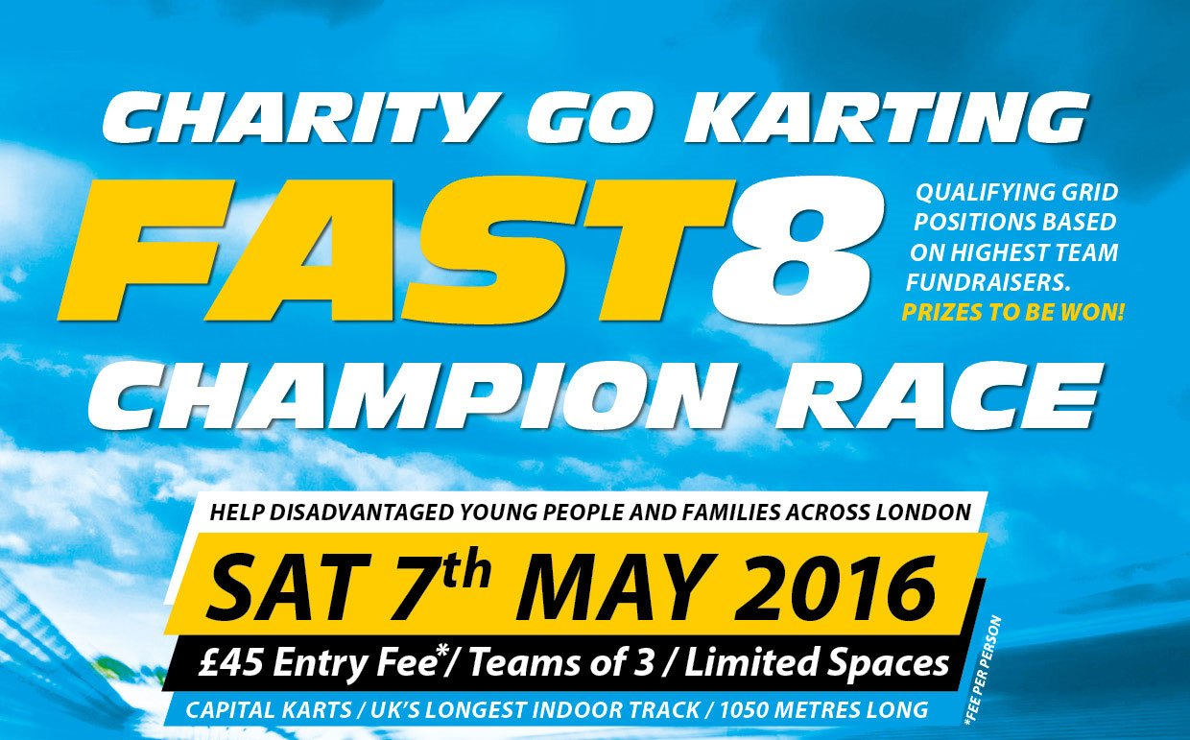
Are you up for a challenge?
Do you want to help vulnerable young people and families?
Are you and you’re team ready to challenge for FAST 8?

Join us for the Osmani Trust’s charity Go Karting challenge FAST 8 on the 7th of May 2016 (Saturday)
Why Fund Raise?
To support the Osmani Trust to provide a range of vital youth, health, mentoring and training/employment services to vulnerable and disadvantaged young people, adults and families across Tower Hamlets and East London.
Itinerary
Date: 7th of May 2016
Venue meeting point: Capital Karts - Unit 1 Rippleside Commercial Estate, London IG110RJ
Time: 10:15am
Race time: 11am
All teams will need to arrive at venue 10:15am for briefing and rules.
Teams will participate in 20 minutes of practice sessions than approximately 70 minutes of action packed racing.
Race positions are based on team’s who have fundraises the highest amount out of the competing teams.
Registration
Registration Price = £45 per person (£135 per team)
Price includes:
• Go Karting race
• Refreshments
• Prizes

How to register:
• You will need to complete an online application form.
http://uk.virginmoneygiving.com/fund/Fast8
This will lead you on to this page…
Click ‘Start Fundraising’
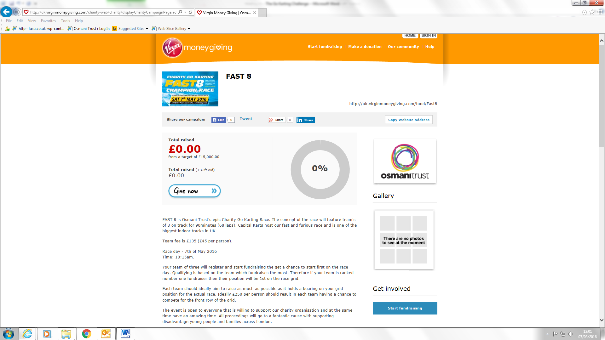

Followed by ‘Organised event’
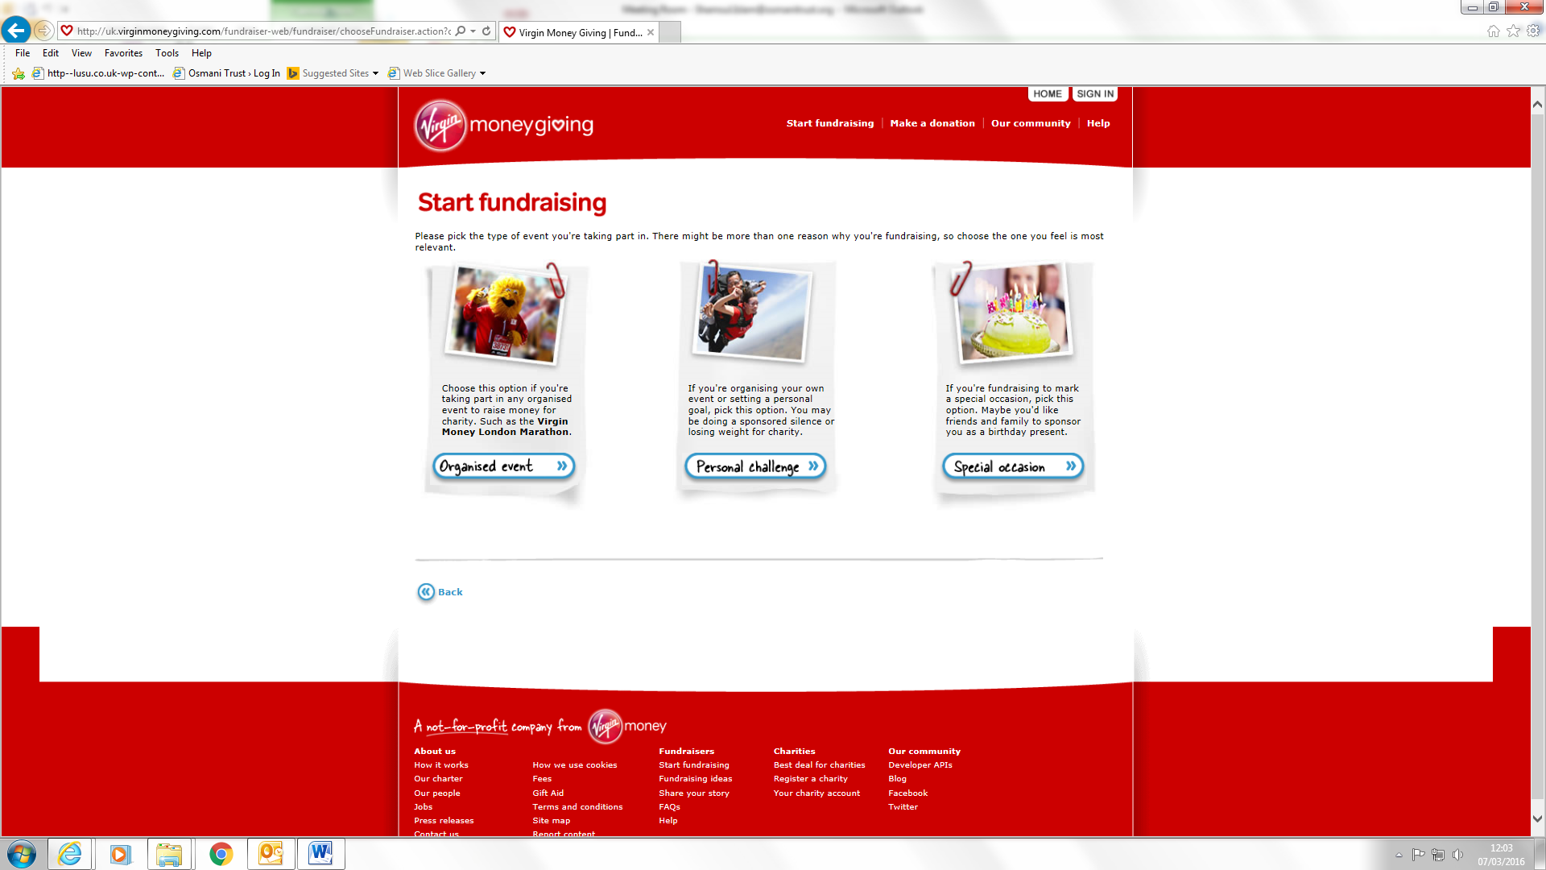

Under Events Name, type ‘FAST 8’
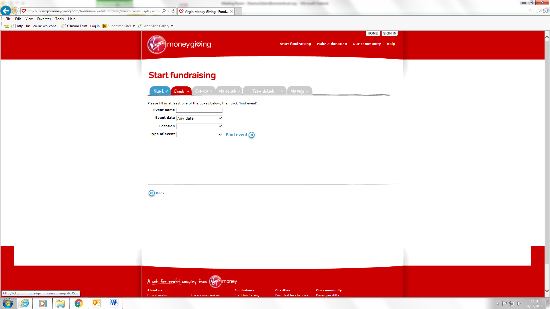

Lastly copy the following information on to your application
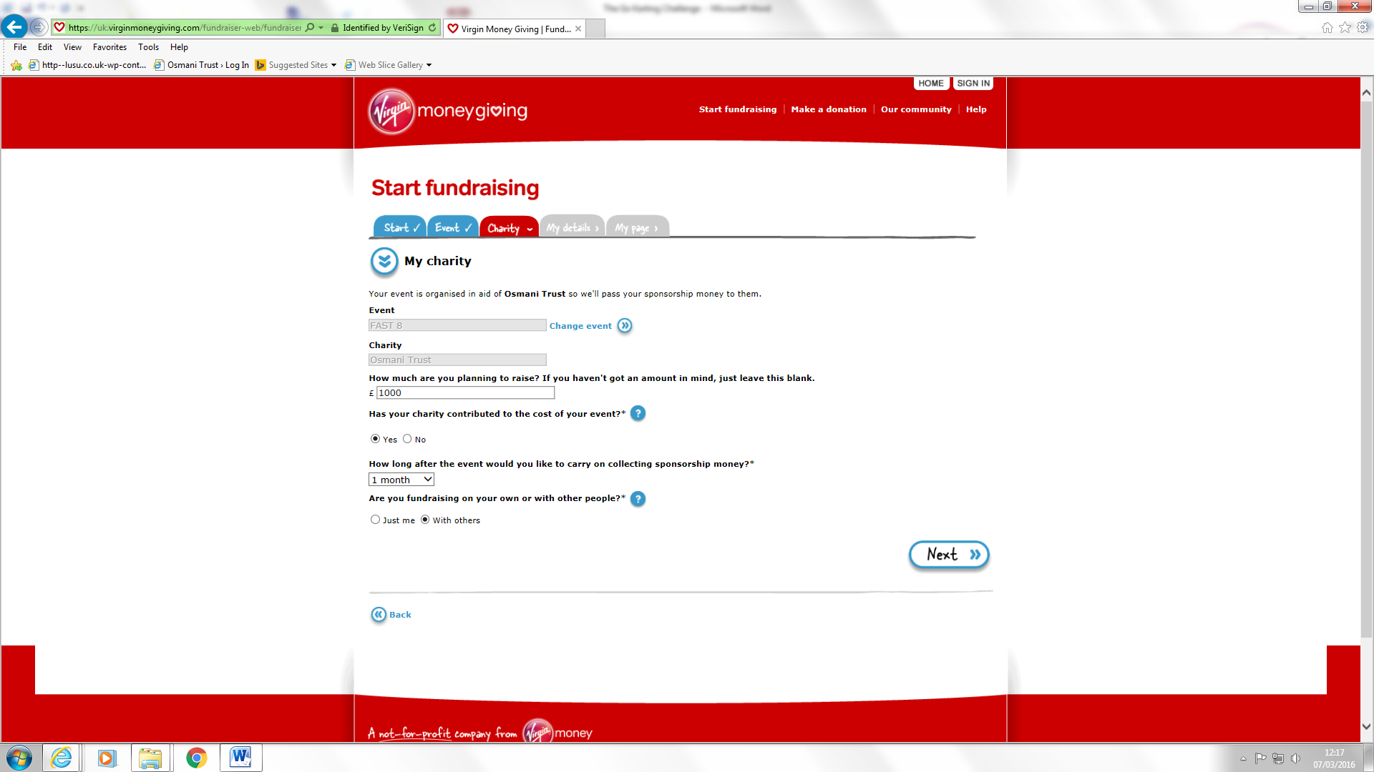

All you do in the next step is register you details and create your page and start fundraising for Osmani Trust. Happy fundraising!!
Don’t forget the race grid positions are based on top fundraising ranks.

Fundraising Tips
We are asking each team to raise attempt to raise £1000. This may seem a lot but is not as hard as it seems.
Here are some tips.
Compete against your friends taking part. The competition can bring some excitement into fundraising and can force you to challenge your own fund raising abilities. Why not set up a weekly fundraising league table so your friends can all see how everyone is getting on?
Help encourage those lagging behind and motivate others to climb up the league table.
Reminders!
Once you have made everyone you know aware of your fundraising challenge be sure to update your contacts on how the fundraising is going, but don’t overdo it to annoy them.
It’s a good protocol to send a reminder email or text a few days before doing the challenge, and then send an update email or text after completing the challenge. Also try to secure as many verbal pledges as possible that way you can remind these sponsors as much as you want until they actually donate.
You may have to be quite persistent to secure the verbal pledges, but it’s all for a worthy cause. A good way around this is to arrange a get together with a group of friends and then when you feel it is appropriate, mention your charity challenge and be blunt and pose the question “So are you going to sponsor me?” Believe me, without doing this, you probably won’t raise as much as you potentially could.
People are so busy these days that they may see your email or text and intend to sponsor you, but then get side tracked and totally forget. From experience we know tracking down sponsors can be very difficult and time consuming. This is why we are recommending that everyone sets up Virginmoneygiving page

Equipment
All equipment and race clothing will be provided by Capital Karts.

FAQs

How do we travel to Capital Karts

Road
We have ample on-site parking.
From the centre of London: we are located on the A13 approximately 2 minutes east of the North Circular interchange and less than 10 minutes from Canary Wharf.
From the M25: we are located west of junction 30 on the A13 approximately 10 minutes in towards London. Turn left at the first traffic lights you come to on the A13.

Rail
From London Fenchurch St: take the C2C services to Barking which run every 3 – 8 minutes.
Underground: District line – Becontree is the closest tube less than 20 minutes walk away.
Hammersmith and City/Overground: Barking station is the closest stop giving the option to change to the district line, or take a short bus/taxi ride to the venue.
DLR: Take services to West Ham station and change to District line/C2C rail services to Barking

Bus
From Barking station/town centre: take bus 287 alighting at the Creekmouth, Renwick Rd stop which is directly in front of the venue.

Will there be any qualified first-aiders?
Yes there will be a qualified first-aider.
When shall I arrive at the venue?
Please arrive no later than 10:15am for the briefing and rules of the competition.
The race will commence 11am sharp.

