**PRESS RELEASE**

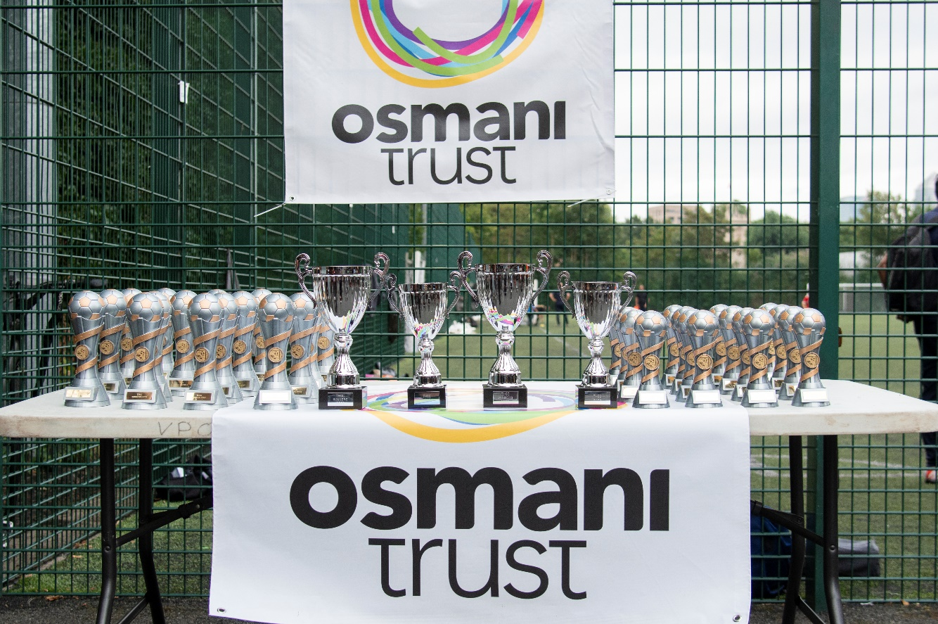**Celebrating Youth, Diversity, and Community Spirit at the 17th Tower Hamlets Community Cup**

The 17th Annual Tower Hamlets Community Cup took place at Stepney Green Park (Tower Hamlets) Astro on Tuesday 29th July 2025, bringing together more than 600 young people, parents, supporters and guestsfor a lively day of sport, teamwork, and connection.

Local teams from across the borough took part in friendly but competitive matches that showcased real talent, teamwork, and the best of community spirit. From start to finish, the day was marked by great sportsmanship, high energy, and a warm, welcoming atmosphere.

Reflecting on the success of the event, local Councillor Abu Chowdhury and Cabinet Member for Safer Communities from LBTH praised the organisation:

“Really great turn out. It takes a lot to organise an event like this, well done to everyone who put this event together.”

The event was also noted for fostering a strong sense of unity and inclusion across the community.

Players, families, and supporters filled the pitches and stands, creating a vibrant backdrop as young people from different age groups played with determination and pride. While the competition was fierce, the focus remained on participation, learning, and respect, values at the heart of the Community Cup.

Harun Khan, our newly appointed Executive Director, said:

“It was an incredible day engaging with so many talented and passionate young footballers from all corners of our community. Their energy, drive, and sportsmanship were truly inspiring. I’m excited to see Osmani Trust continue to build on this success and deliver even greater events in the future.”

**Final Results**

Below are the winners and runners-up in each age category:

| **Winners** | **Runners-Up** | **Age Group** | |
| --- | --- | --- | --- |
| Central Tigers | Mindset FC | Under 8s |
| Vallance | Elite FA | Under 10s |
| Onside Football | Vallance | Under 12s |
| CPA Lions | Onside Football | Under 14s |
|  |  |  |

Tower Hamlets Community Cup remains committed to using sport as a vehicle for youth development, community building, and celebrating the borough’s diversity. The event also continues to spotlight local services and organisations working to support young people and families throughout the year.

This year’s success is thanks to the **incredible teamwork and dedication** of everyone involved — staff, volunteers, coaches, parents, and young players alike. Their combined efforts created a positive and inclusive atmosphere that was felt by all.

**The Tower Hamlets Community Cup continues to grow**, both in scale and in impact. We look forward to building on this momentum and delivering more opportunities for young people to come together, stay active, and celebrate the spirit of community through sport.

“The event was a fantastic example of community cohesion. It brought together people from diverse backgrounds, creating a warm, inclusive atmosphere where everyone felt welcome. It was inspiring to see genuine connections being formed.” Sana Miah (Health & Development Officer – Osmani Trust)

-Ends –

**Notes to Editors**

* Osmani Trust is a youth and community organisation based in Tower Hamlets. The Trust offers a wide range of youth, social welfare, health, and sporting initiatives tailored to the needs of the community. It aims to provide a holistic service, which helps people, particularly those living in disadvantaged urban communities, to re-engage with mainstream society and improve their quality of life.
* Through its provisions, Osmani Trust seeks to address issues impacting the community including substance misuse, racial tensions, criminality and anti-social behaviour, territoriality and gang-related violence, unemployment and overcrowding, lack of training and employment opportunities. It also places strong emphasis on the health and social welfare of the community.
* Osmani Trust works with ordinary people, helping them to do extraordinary things.

For more information about this event, please contact Sana Miah on [sana.miah@osmanitrust.org](mailto:sana.miah@osmanitrust.org) or 020 7247 8080.

For information on Osmani Trust and its work please visit [www.osmanitrust.org](https://www.osmanitrust.org/)